From:

Who is Massimo Stecchini, the current love of Pepa Flores who changed her life
By:

Mireya BrownMadrid
10/23/2019 21: 51h.
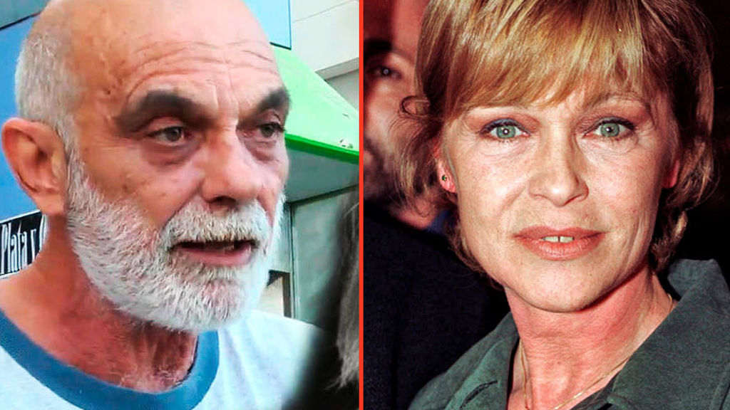
Massimo Stecchini and Pepa Flores TELECINCO / EUROPA PRESS
- She has lived happily for 30 years with an Italian, 11 years younger, in a house with a vegetable garden and chickens in Malaga
- He exploded on television asking the media to respect the anonymity chosen by his wife
- It is Marisol's third partner, after Carlos Goyanes and the father of her daughters, Antonio Gades
Pepa Flores has been retired from public life for 30 years. Much has been speculated on the reasons for this voluntary abandonment of the lights. But those who know her well, mainly her family, say that there is not so much mystery. Simply, the actress found happiness, and above all, "the center and rest" that Lope de Vega wrote to define love.
In her search for a normal life , she saw the perfect partner in Massimo Stecchini, 11 years her junior and her partner of 3 decades. In Marisol's case, it could be said that the third time was the charm. They say that her great love would not be her first husband, Carlos Goyanes , not even Antonio Gades , father of her three daughters and partner for 13 years. The man in her life, at least the current one, is this Italian with whom she resides in her hometown, Malaga, away from the spotlight.
…………………………………………..
………….

